Dooster Time Error
Thursday is marked as the recurring day, but the due date shows up as 4/23/14. Time was already changed to Arizona Mountain time in settings, so this error should not occur.
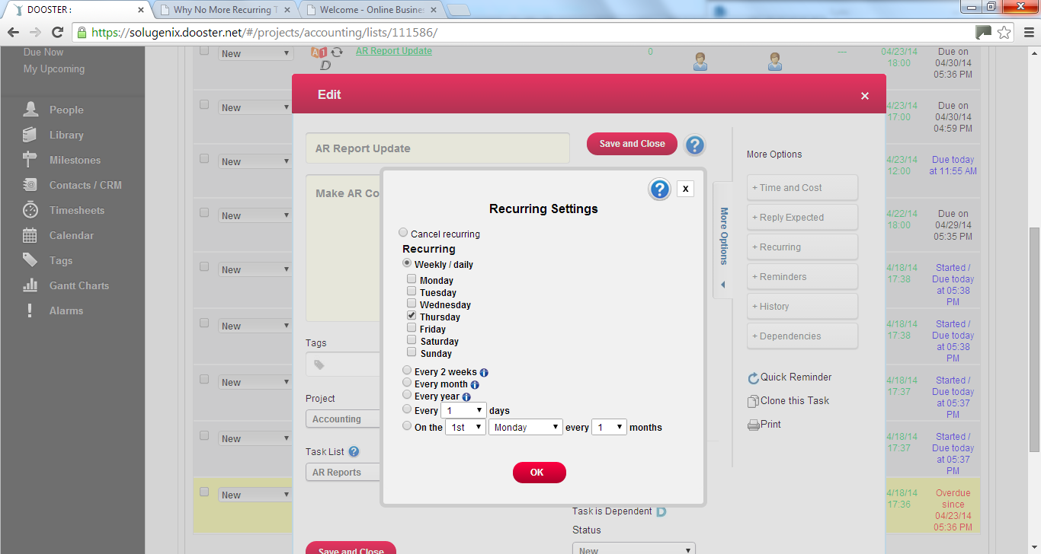
4/23/14 is Wednesday in USA, not Thursday.
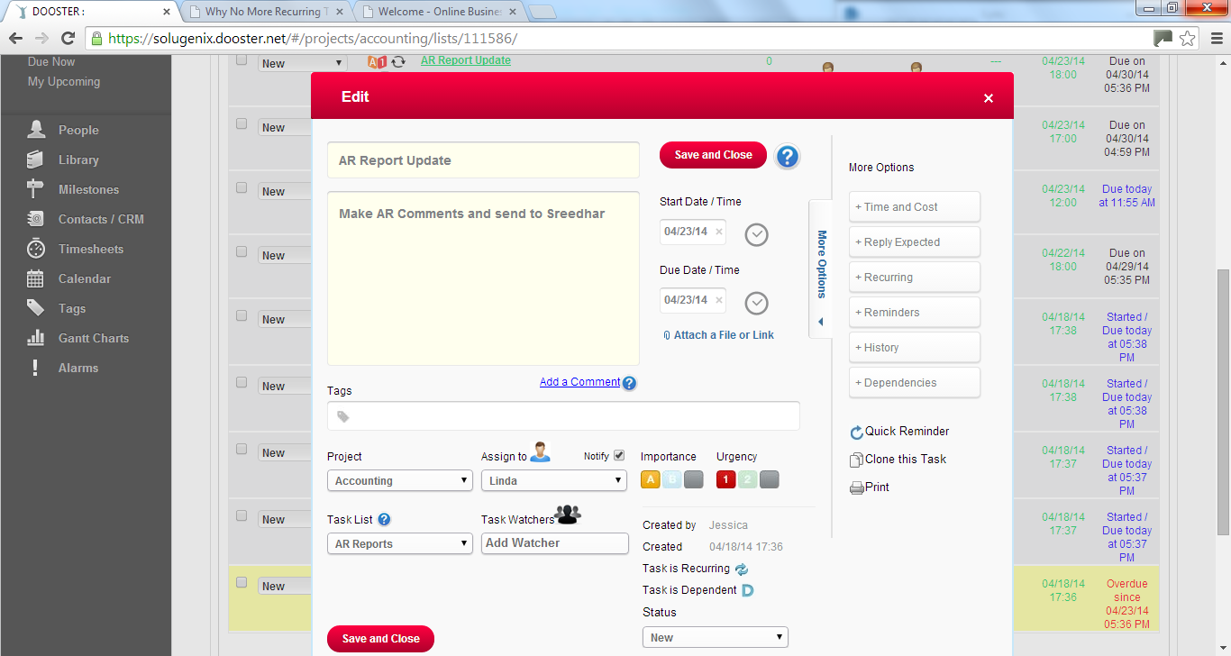
Can this be because Dooster is still programmed as in UK time? Keep in mind we already changed the time in settings to local time.

