It will not let me open the task:
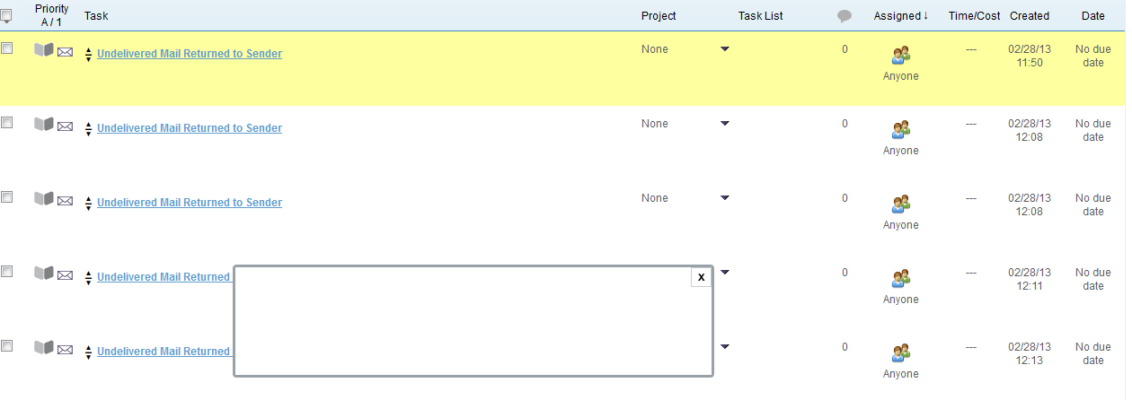
I was not able to capture the dropdown other than on video. I hope it gets you what you need.
Video:
http://screencast.com/t/6Gax9nLCDE

