- I was in the Projects Tasks section
- I was adding new tasks in a task list, eg. Employee Liability Recon-GL#205004-Accrued Employee Commissions Payable
- I was checking off the due dates box for all the dependent tasks
- After finishing, the due date area has a due date that is even different then the parent task and does not read Waiting for Parent as it should:

The parent task has a start date and due date:
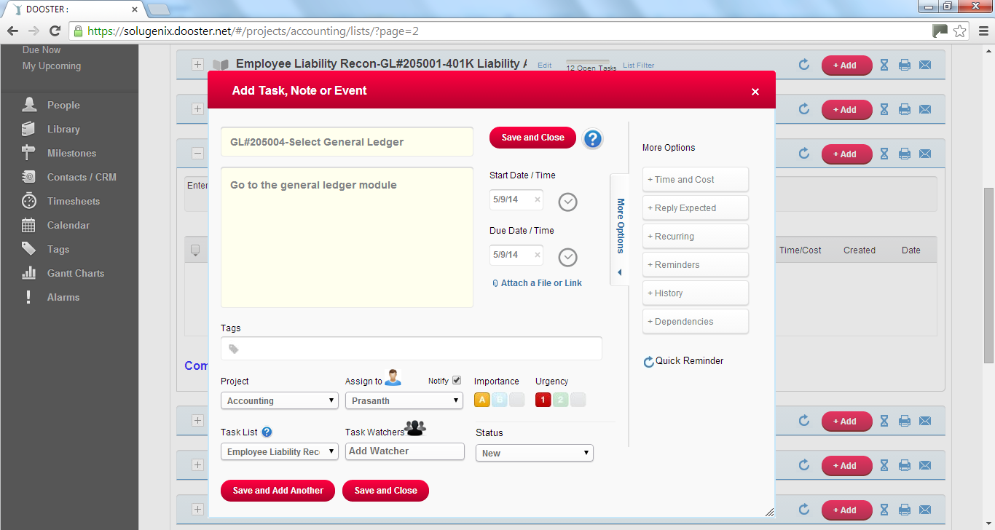
The dependent task does not:
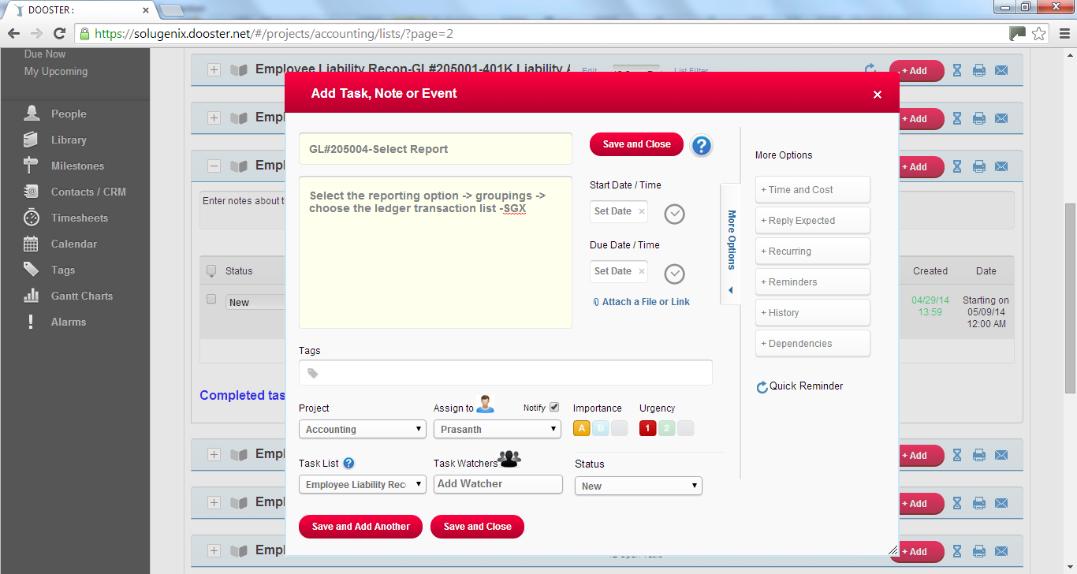
But in the Dependencies section, the Due Date box is checked:
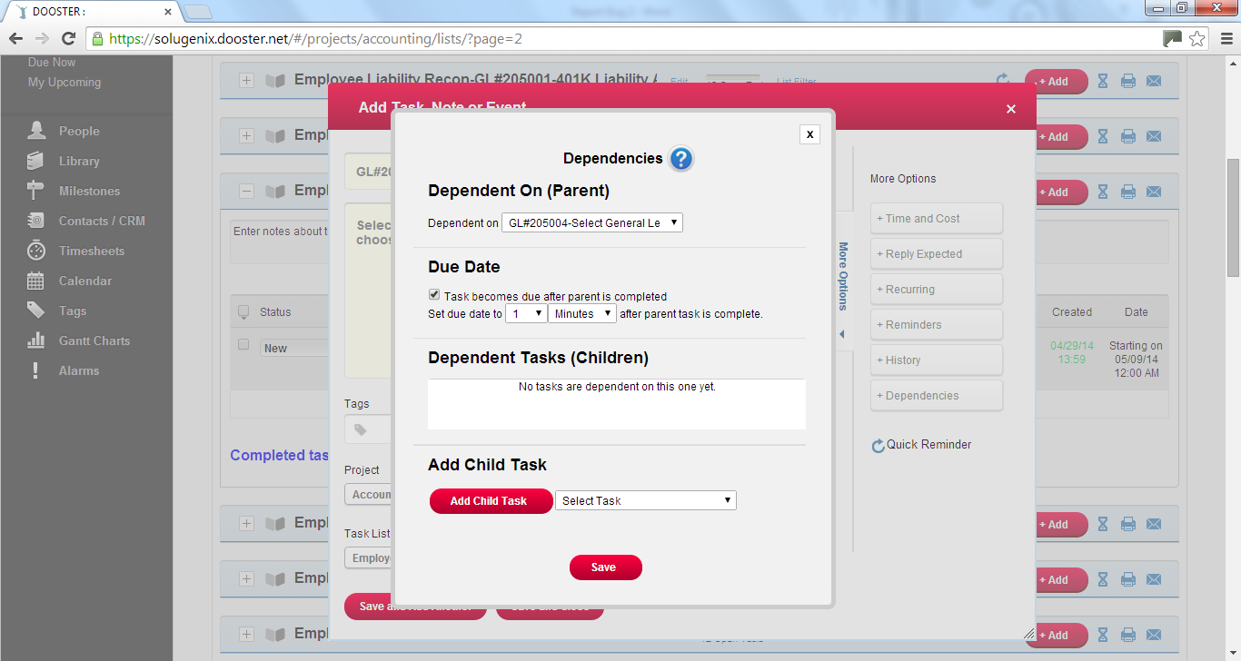
When I save and close, the task I just added has a due date, which I did not set up.
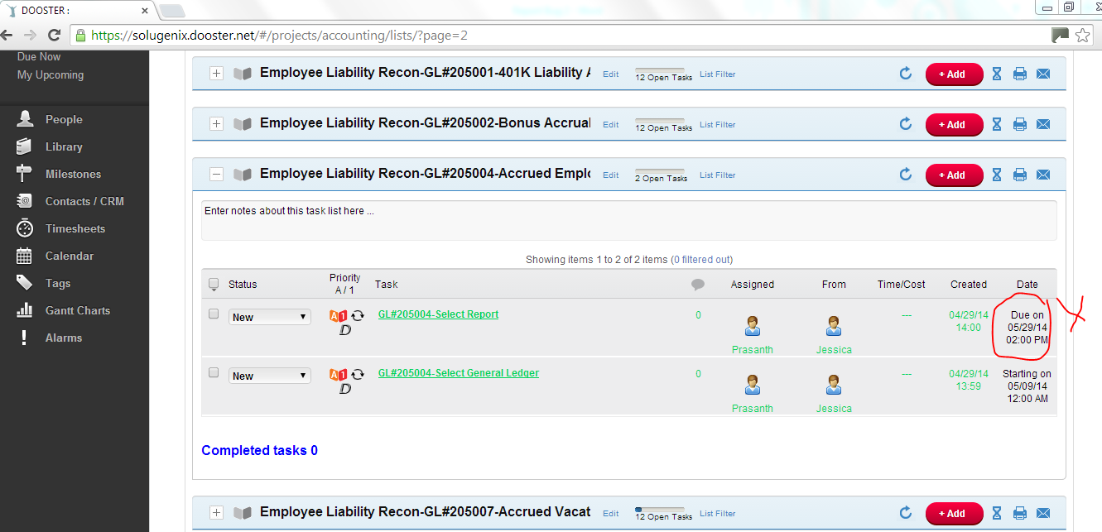
This must be a bug as I expect that area to say Waiting for Parent.
Then I go in to select the actual due date:
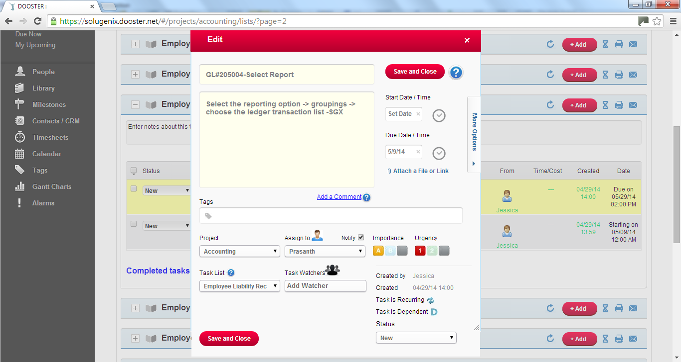

After saving and closing, it will say Waiting for Parent:
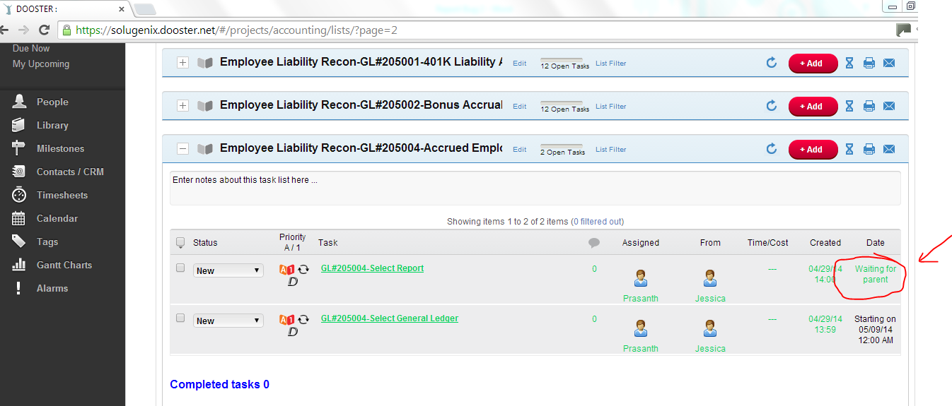
Why must this extra step take place?

If it is waiting for parent, it will become due when parent task is completed, thus, not needing a due date right?
Why must I go in again to reedit the due date to make it Waiting for Parent when it should have turned Waiting for Parent when I was done editing the task?

