Bug reports
We test Dooster regularly but like any software it can have bugs. It is so important to us to have as perfect an app as possible that we will reward you. Report a bug in the following way and get TWO FREE MONTHS.

How to report a Bug
It can be very difficult to (a) understand and (b) reproduce bugs. It makes a huge difference in time and effort if you can report them as follows:
1) I was in the Main section (eg “I was in the Dashboard”
2) Doing Sub section / activity::: (eg “I was using the Filters”)
3) I was trying to::: (eg “I was filtering tasks assigned to Tom between the dates June and December).
4) What was wrong / The BUG ::: (eg "The BUG: It showed me tasks in January as well)

Screenshots (pictures of your screen) can also be very helpful. A picture paints a thousand words.. They are very easy to create. See this quick guide

- I was in the Tasks section in Projects
- I was scrolling through task lists and using the expand function
- I was trying to find tasks underneath the task list
- What was wrong was the recurring tasks no longer show:
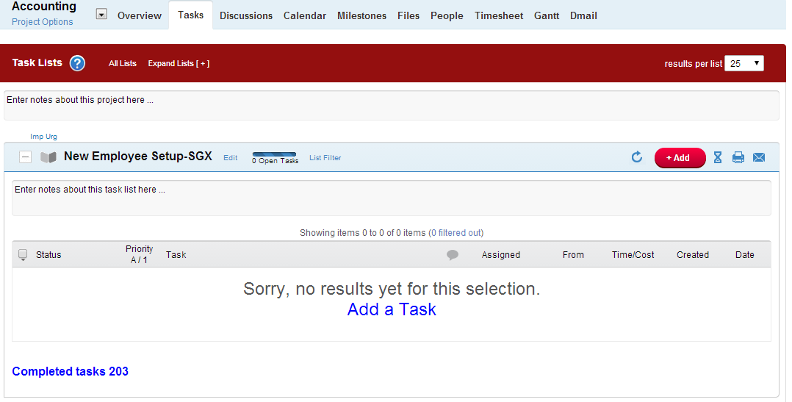
Same here:
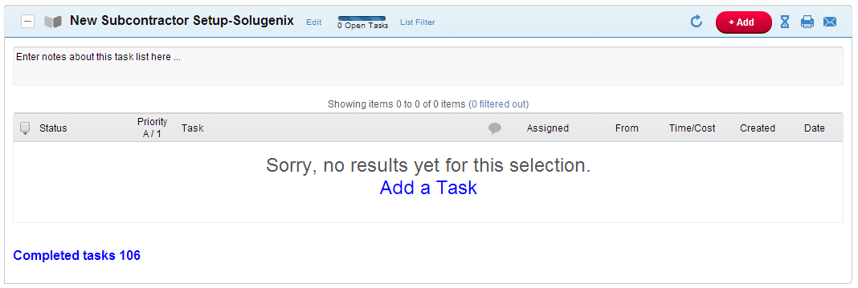

Same here:

