- I was in the Tasks section in Projects
- I was scrolling through task lists and using the expand function
- I was trying to find tasks underneath the task list
- What was wrong was the recurring tasks no longer show:
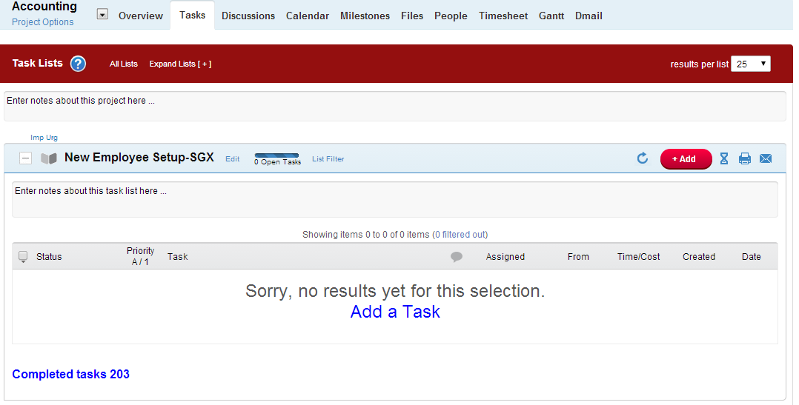
Same here:
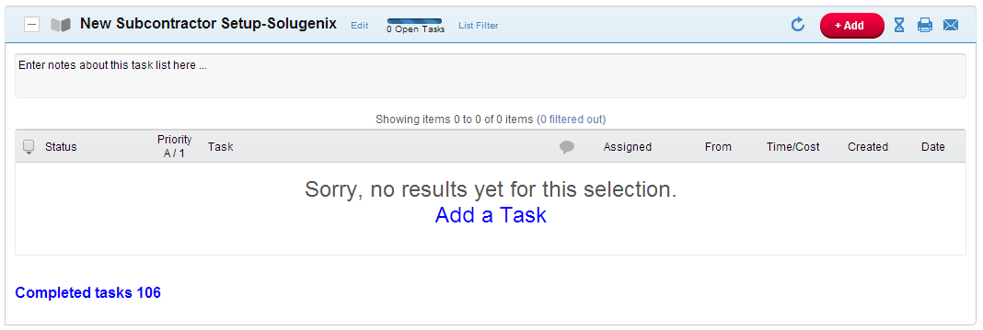

Same here:

